LEED 2009 – EQc8.2, LEEDv4 – Quality Views
Requirements LEED 2009 (BD+C & ID+C)
Achieve a direct line of sight to the outdoor environment via vision glazing between 30 inches and 90 inches (between 0.8 meters and 2.3 meters) above the finish floor for building occupants in 90% of all regularly occupied areas. Determine the area with a direct line of sight by totaling the regularly occupied floor area that meets the following criteria:
- In plan view, the area is within sight lines drawn from perimeter vision glazing.
- In section view, a direct sight line can be drawn from the area to perimeter vision glazing.
The line of sight may be drawn through interior glazing. For private offices, the entire floor area of the office may be counted if 75% or more of the area has a direct line of sight to perimeter vision glazing. For multi-occupant spaces, the actual floor area with a direct line of sight to perimeter vision glazing is counted.

Requirements LEED v4:
Achieve a direct line of sight to the outdoors via vision glazing for 75% of all regularly occupied floor area. View glazing in the contributing area must provide a clear image of the exterior, not obstructed by frits, fibers, patterned glazing, or added tints that distort color balance.
Additionally, 75% of all regularly occupied floor area must have at least two of the following four kinds of views:
- Multiple lines of sight to vision glazing in different directions at least 90 degrees apart;
- Views that include at least two of the following: (1) flora, fauna, or sky; (2) movement; and (3) objects at least 25 feet from the exterior of the glazing;
- Unobstructed views located within the distance of three times the head height of the vision glazing; and
- Views with a view factor of 3 or greater, as defined in “Windows and Offices; A Study of Office Worker Performance and the Indoor Environment.”

Include in the calculations any permanent interior obstructions. Movable furniture and partitions may be excluded.
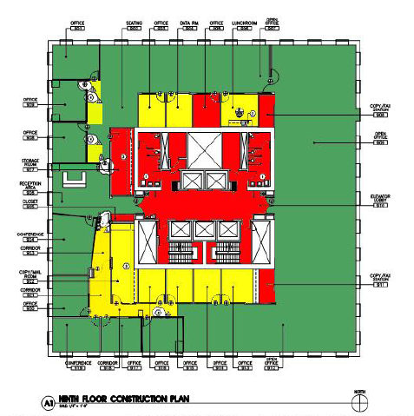
Views into interior atria may be used to meet up to 30% of the required area.

Figure 1. Sample Plan for Direct View Calculation
Above is a sample plan that demonstrates the increase in direct line of sight to outdoor glazing that results form the use of Avanti transparent partitions, walls and doors. The green shaded region represents the direct line sight area of regularly occupied spaces that is standard based on the design and layout of the floor. The red region represents spaces that are not regularly occupied (i.e. closets, storage rooms, elevator bank). The yellow shaded region are the spaces that have direct line of sight to outdoor glazing because of the use of Avanti products. As you can see there is a significant increase in the area that has direct sight lines to the outdoors. For LEED, EQc8.2 (see above) states that to

receive a point 90% of all regularly occupied spaces must have a direct line to the outdoor environment. In the scenario represented by the sample plan, before the implementation of Avanti products an estimated 81% of spaces would have access to exterior glazing, not qualifying the space for a point under LEED EQc8.2. After the Avanti products are put in place the area with direct line of sight to the outdoor environment increases to 99%, qualifying the space for a point. See Figure 2 for calculations.

Direct View Calculation
Total Square Footage | 24,400
Not regularly Occupied Spaces (Red) | -5,625
Total Occupied Space | 18,775
Occupied with Access to Views without Avanti Partitions and walls (Green) | 15,175
Percent Access with Views | 81%
Occupied with Access to Views with Avanti Partitions and walls (Yellow) | 3,350
Percent Access with Views | 18%

Figure 2. Calculation for EQc8.2

