LEED 2009 – MRc5, LEEDv4 – Environmental Product Declarations, Opt. 2
Requirements LEED 2009 (BD+C)
Use building materials or products that have been extracted, harvested or recovered, as well as manufactured, within a specified distance of the project site for a minimum of 10% or 20%, based on cost, of the total materials value. If only a fraction of a product or material is extracted, harvested, or recovered and manufactured locally, then only that percentage (by weight) must contribute to the regional value. The minimum percentage regional materials for each point threshold is as follows:

Regional Materials | Points
10% | 1
20% | 2

Option 1
All building materials or products have been extracted, harvested or recovered, as well as manufactured with a 500 mile (800 kilometer) radius of the project site.
OR
Option 2
Building materials or products shipped by rail or water have been extracted, harvested or recovered, as well as manufactured within a 500 mile (800 kilometer) total travel distance of the project site using a weighted average determined through the following formula:
(Distance by rail/3) + (Distance by inland waterway/2) + (Distance by sea/15) + (Distance by all other means) < 500 [800 kilometers]

Requirements LEED 2009 (ID+C)
Option 1
Use a minimum of 20% of the combined value of construction and Division 12 (Furniture) materials and products that were manufactured regionally within a radius of 500 miles (800 kilometers).
OR
Use a minimum of 20% of the combined value of construction and Division 12 (Furniture) materials and products that are manufactured regionally within a 500 mile (800 kilometer) total travel distance of the project site using a weighted average determined through the following formula:
(Distance by rail/3) + (Distance by inland waterway/2) + (Distance by sea/15) + (Distance by all other means) < 500 [800 kilometers]
Option 2
Meet the requirements for Option 1.
AND
Use a minimum of 10% of the combined value of construction and Division 12 (Furniture) materials and products extracted, harvested or recovered, as well as manufactured, within 500 miles (800 kilometers) of the project.
OR
Use a minimum of 10% of the combined value of construction and Division 12 (Furniture) materials and products extracted, harvested or recovered, as well as manufactured regionally within a 500 mile (800 kilometer) total travel distance of the project site using a weighted average determined through the following formula:
(Distance by rail/3) + (Distance by inland waterway/2) + (Distance by sea/15) + (Distance by all other means) < 500 [800 kilometers]

Calculations
Material costs include all expenses to deliver the materials to the project site. Material costs should account for all taxes and transportation cost incurred by the contractor but exclude any costs for labor and equipment once the material has been delivered to the site.
For assemblies or products manufactured within the 500-mile radius that contain some components extracted farther away, use multiple lines when listing purchases. Base the proportionality of such products’ costs on the weight of their various components.

Requirements LEED v4
Option 2
Use products that comply with one of the criteria before for 50%, by cost, of the total value of permanently installed products in the project. Products will be valued as below.
- Third party certified products that demonstrate impact reduction below industry average in at least three of the following categories are valued at 100% of their cost for credit achievement calculations.
  - Global warming potential (greenhouse gases), in CO2e;
  - Depletion of stratospheric ozone layer, in kg CFC-11;
  - Acidification of land and water sources, in moles H+ or kg SO2;
  - Eutrophication, in kg nitrogen or kg phosphate;
  - Formation of tropospheric ozone, in kg NOx, kg O3eq, or kg ethane; and
  - Depletion of nonrenewable energy resources, in MJ.
- USGBC approved program – Products that comply with other USGBC approved multi-attribute frameworks.

For credit achievement calculation, products sourced (extracted, manufactured, purchased) within 100 miles (160 km) of the project site are valued at 200% of their base contributing cost.

Avanti Products Contribution:
Recycled Content Calculator
Material | Manufacturer | Weight of Material | Location of Extraction, Harvesting, or Recovery | Within 500 Miles of Project Site | Weight Contributing to Regional Material
1 (2) 5x9 pieces of glass | Glass Dynamics | 495.0 | Carlilse, PA¹ | Yes² | 495.0
2 Double Glazed Base Channel | Avanti Systems UK | 4.2 | United Kingdom | No | 0
3 Double Glazed Head Channel | Avanti Systems UK | 4.2 | United Kingdom | No | 0
4 H-Channel | Avanti Systems UK | 0.8 | United Kingdom | No | 0
5 Hardware | CR Laurence | 5.0 | Los Angeles, CA | No³ | 5.0
Totals: |  | 509.2 |  |  | 495.0
Percent Recycled Content According to LEED |  |  |  |  | 97%
ID&C Option 2 and BD&C entire credit – Extracted, harvested, or recovered as well as manufactured regionally:
As Avanti received material from all over the US and Europe, their entire product will not qualify for Option 2 of the ID&C credit or the BD&C credit. LEED mandates that products must be extracted, harvested or recovered, as well as manufactured, within 500 miles of the project. However, a fraction of Avanti’s products will qualify for this credit. These percentages are calculated by weight. See the example below:

Figure 1: Regional Materials Example Calculation
1: For this example Avanti’s location is used as the Project Site. The glass manufacturer used is in PA. Avanti retains the services of many glass manufacturers across the United States.
^{2:} If the Project Site is within 500 miles of Los Angeles, CA the hardware may contribute toward the Regional Materials credit.

The dominance of the glass, which is extracted within 200 miles of the manufacturing point of Greenwich, CT, allows a potential of 93% of an Avanti product to count towards the regional credit.
The final regional material calculation is done by cost. Products, like Avanti’s, who only contribute a percentage of their total weight to this credit must multiply this percentage by the total cost of the product.

Cost of Regional Material = Percentage of local material (by weight) * Total Cost of Product
^{Equation 1}

Note: This calculator does not guarantee a project will get a percentage of points for implementing Avanti products as it depends on the location of the project. The calculator lists the materials that could possibly qualify for this credit.
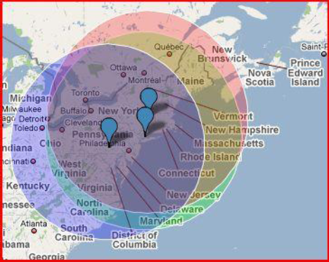

Figure 2: Overlapping 500 mile radii of Manufacturing and Extraction points
Blue = Glass Dynamics (Carlisle, PA)
Green = Avanti Manufacturing Point (Greenwich, CT)
Red = LTI Smart Glass (Lenox, MA)

Avanti products have two possible glass types, LCD or regular glass. Depending on the choice of glass selected, the project location needs to be located within the intersection of two of the three 500 mile radii to receive some contribution of this credit. The project must be within 500 miles of the manufacturing point, Greenwich, CT; to contribute to all this or any Regional Material credit. As a good portion (weight) of Avanti products are made up of glass, having the glass source close to the point of manufacture means most of Avanti’s products have the potential to contribute to this credit.

LEED 2009 (ID+C) Credit MR5
Option 1 Requirements
Use a minimum of 20% of the combined value of construction and Division 12 (Furniture) materials and products that were manufactured regionally within a radius of 500 miles.
Avanti Product Contribution:
For this option in LEED ID&C, the manufacturing point is what is important. According to LEED,
“The point of manufacture is considered the place of final assembly of components into the building product that is furnished and installed by the trade’s workers. For example, if the hardware comes from Dallas, the lumber comes from Vancouver, and the joist is assembled in Kent, Washington, then the location of the final assembly is Kent, Washington.”
Below is a map that shows the area within a 500 mile radius of Greenwich, CT, the location of manufacturing.

Figure 3: 500 mile radius from Greenwich, CT manufacturing point
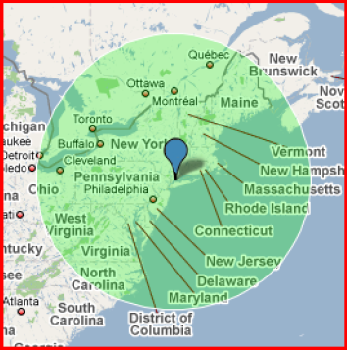
For any project located in this region, Avanti’s products will fully contribute to Option 1 of LEED ID&C Credit MR5.

