LEED 2009 – EQc8.1, LEEDv4 – Daylight
Requirements LEED 2009 (BD+C & ID+C)
Through 1 of the 4 options, achieve daylighting in at least the following spaces:
Regularly Occupied Spaces | Points
75% | 1
90% | 2

Option 1. Simulation
Demonstrate through computer simulation that the applicable spaces achieve daylight illuminance levels of a minimum of 10 footcandles (fc) (108 lux) and a maximum of 500 fc (5,400 lux) in a clear sky condition on September 21 at 9 a.m. and 3 p.m.
Provide glare control devices to avoid high-contrast situations that could impede visual tasks. However, designs that incorporate view-preserving automated shades for glare control may demonstrate compliance for only the minimum 10 fc (108 lux) illuminance level.
Option 2. Prescriptive
For sidelighting zones:
- Achieve a value, calculated as the product of the visible light transmittance (VLT) and window-to-floor area ration (WFR) between 0.150 and 0.180.

0.150 < VLT X WFR < 0.180
- The window area included in the calculation must be at least 30 inches (0.8 meters) above the floor.
- In section, the ceiling must not obstruct a lien that extends from the window-head to a point on the floor that is located twice the height of the window-head from the exterior wall as measured perpendicular to the glass (see Figure 1).

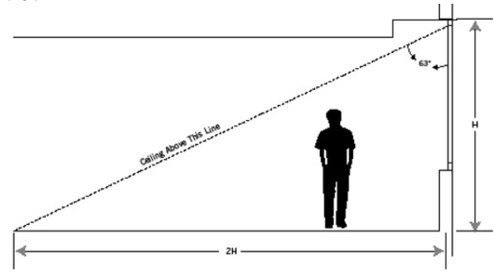

^{Figure 1}
- Provide glare control devices to avoid high-contrast situations that could impede visual tasks. However, designs that incorporate view-preserving automated shades for glare control may demonstrate compliance for only the minimum 0.150 value.
For Toplighting zones:
- The toplighting zone under a skylight is the outline of the opening beneath the skylight, plus in each direction the lesser of (see Figure 2).
  - 70% of the ceiling height
  - 1/2 the distance to the edge of the nearest skylight
  - The distance to any permanent partition that is closer than 70% of the distance between the top of the partition and the ceiling.
  - Achieve skylight coverage for the applicable space (containing the top-lighting zone) between 3% and 6% of the total floor area.
  - The skylight must have a minimum 0.5 VLT.
  - A skylight diffuser, if used, must have a measured haze value of greater than 90% when tested according to ASTM D1003.

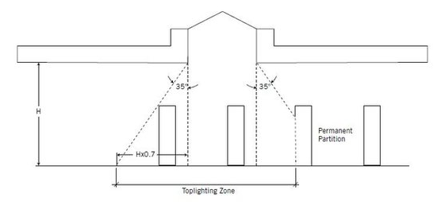

^{Figure 2}
Option 3. Measurement
Demonstrate through records of indoor light measurements that a minimum daylight illumination level of 10 fc (108 lux) and a maximum of 500 fc (5,400 lux) has been achieved in the applicable spaces. Measurements must be taken on a 10-foot (3-meter) grid and shall be recorded on building floor plans.
Provide glare control devices to avoid high-contrast situations that could impede visual tasks. However, designs that incorporate view-preserving automated shades for glare control may demonstrate compliance for only the minimum 10 fc (108 lux) illuminance level.

Option 4. Combination
Any of the above calculation methods may be combined to document the minimum daylight illumination in the applicable spaces.

Requirements LEED v4:
Provide manual or automatic (with manual override) glare-control devices for all regularly occupied spaces.
Select one of the following three options.
Option 1. Simulation: Spatial Daylight Autonomy (2-3 points, 1-2 Healthcare)
New Construction, Core and Shell, Schools, Retail, Data Centers, Warehouses & Distribution Centers, CI, Hospitality |  | Healthcare
sDA (for regularly occupied floor area | Points | sDA (for perimeter floor area | Points
55% | 2 | 75% | 1
75% | 3 | 90% | 2
Demonstrate through annual computer simulations that spatial daylight autonomy_{300/50%} (sDA_{300/50%}) of at least 55%, 75% or 90% is achieved. Use regularly occupied floor area. Healthcare projects should use the perimeter area determined under EQ Credit Quality Views. Points are awarded according to Table 1.

Table 1. Points for daylit floor area: Spatial daylight autonomy
AND
Demonstrate through annual computer simulations that annual sunlight exposure_{1000,250} (ASE_{1000,250}) of no more than 10% is achieved. Use the regularly occupied floor area that is daylit per the sDA_{300/50%} simulations.
The sDA and ASE calculation grids should be no more than 2 feet (600 millimeters) square and laid out across the regularly occupied area t a work plane height of 30 inches (76 millimeters) above finished floor (unless otherwise defined). Use an hourly time-step analysis based on typical meteorological year data, or an equivalent, for the nearest available weather station. Include any permanent interior obstructions, Movable furniture and partitions may be excluded.

Option 2. Points for daylit floor area: Illuminance calculation
Demonstrate through computer modeling that illuminance levels will be between 300 lux and 3,000 lux for 9 a.m. and 3 p.m. both on a clear-sky day at the equinox, for the floor area indicated in Table 2. Use regularly occupied floor area. Healthcare projects should use the perimeter area determined under EQ Credit Quality Views.

New Construction, Core and Shell, Schools, Retail, Data Centers, Warehouses & Distribution Centers, CI, |  | Healthcare
Percentage of regularly occupied floor area | Points | Percentage of perimeter floor area | Points
75% | 1 | 75% | 1
90% | 2 | 90% | 2

Table 2. Points for daylit floor area: Illunimance calculation
Calculate illuminance intensity for sun (direct component) and sky (diffuse component) for clear-sky conditions as follows:
- Use typical meteorological year data, or an equivalent, for the nearest available weather station.
- Select one day within 15 days of September 21 and one day within 15 days of March 21 that represent the clearest sky condition.
- Use the average of the hourly value for the two selected days.
Exclude blinds or shades from the model. Include any permanent interior obstructions. Movable furniture and partitions may be excluded.

Option 3. Measurement (2-3 points, 1-2 points Healthcare)
Achieve illuminance levels between 300 lux and 3,000 lux for the floor area indicated in Table 3.

New Construction, CS, Schools, Retail, Data Centers, Warehouses & Distribution Centers, Hospitality, CI |  | Healthcare
Percentage of regularly occupied floor area | Points | Percentage of perimeter floor area | Points
75% | 2 | 75% | 1
90% | 3 | 90% | 2

Table 3. Points for daylit floor area: Measurement
With furniture, fixtures, and equipment in place, measure illuminance level as follows:
- Measure at appropriate work plane height during any hour between 9 a.m. and 3 p.m.
- Take one measurement in any regularly occupied month, and take a second as indicated in Table 4.
- For spaces larger than 150 square feet (14 square meters), take measurements on a maximum 10 foot (3 meter) square grid.
If first measurement is taken in… | take second measurement in…
January | May - September
February | June - October
March | June – July, November - December
April | August - December
May | September - January
June | October - February
July | November - March
August | December - April
September | December – January, May - June
October | February - June
November | March - July
December | April - August
- For spaces 150 square feet (14 square meters) or smaller, take measurements on a maximum 3 foot (900 millimeters) square grid.

Table 4. Timing of measurements for illuminance

Definitions:
Visible Light Transmittance (VLT) is the percentage of visible transparent or translucent openings transmit. Where building owners want plenty of natural light, they opt for high VLT values. Tinted glazings, which block glare by letting in less light, have low VLT ratings.
Avanti’s Products Contribution:
For EQ Credit 8.1 Avanti’s transparent and translucent partitions, walls, and doors improve the daylighting of space. They increase the amount of space that has illuminance levels of 25 fc from natural light while also providing glare control adaptable to each case. The sample plan in Figure 1 (Daylight and Views – view, EQc8.2) provide a similar explanation to the exact contribution of Avanti’s products as they did for EQc8.2. With the correct design of windows and office layout, implementing Avanti’s products should increase the amount of space receiving 25 fc of natural daylight by 20% or more. In the sample plan scenario (Figure 1 Daylight and Views – view, EQc8.2), Avanti’s products will take the project from barely achieving one point to more than qualifying for two points.
Conclusion:
By employing any number of Avanti Systems’ products, a project undergoing LEED certification under Interior Design and Construction or Building Design and Construction will achieve an additional two to three points under EQ Credit 8.1 and 8.2. Avanti’s transparent and translucent walls, partitions and doors not only improve the depth that natural daylight reaches into a space, they also provide adaptable glare control for a multitude of situations.

